Q1 Download the file [scraper.sh](https://hs2solutions-my.sharepoint.com/:u:/g/personal/sharath_ram_bounteous_com/EVjtybZVxKRHjRNAwDkxVIYB_IKgcXaEGaAEjgcYAnTC1Q?e=MwOOxC) . Make the file executable. The file takes any  wikipedia webpage as an argument. Run the process on multiple sites like [Wikipedia:Stub - Wikipedia](https://en.wikipedia.org/wiki/Wikipedia:Stub) , [India - Wikipedia](https://en.wikipedia.org/wiki/India) at the same time and

1. Find all the processes running on the system.
2. Find the first 5 processes with the highest memory usage.

**wget http://example.com/scraper.sh**

**chmod +x scraper.sh**

**./scraper.sh "https://en.wikipedia.org/wiki/Wikipedia:Stub" &**

**./scraper.sh "https://en.wikipedia.org/wiki/India" &**

**ps aux**

**ps aux --sort=-%mem | head -n 6**

Q2. Print the HTTP response code obtained from google.com.



Q3 Find the top 3 running processes which consume the most processing power.

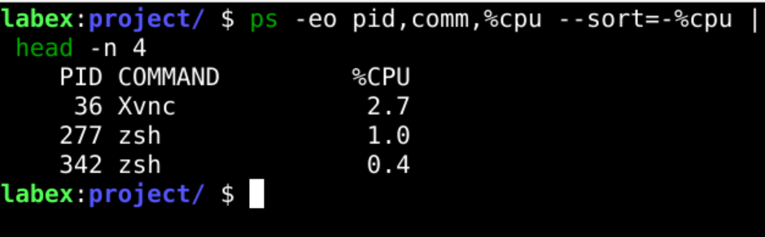

Q4 Write a script that finds all files larger than 100MB in a directory and lists them.

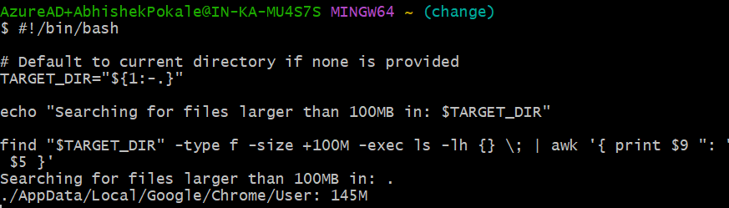

Q5. Find which version of Python is installed on the system.

Python3 –version(Python not installed)

Q6. Get the current time zone of your system.

timedatectl | grep "Time zone"



Q7. Get the current time in New York, London, and Sydney.

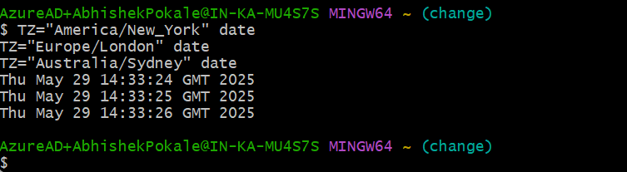

Q8. Check for how long the system is up.

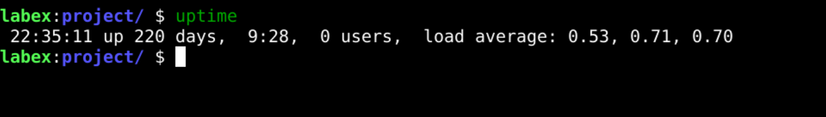

Given a log file:

1. Find all the errors in the log and dump them to a new file.

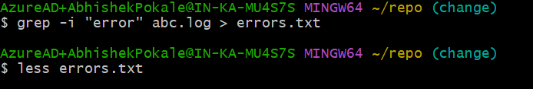

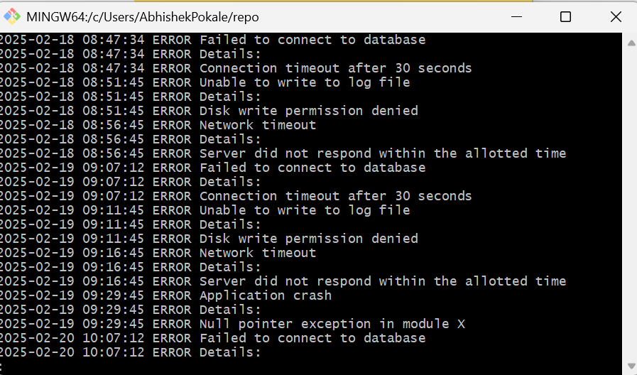

1. What events occurred between 09:10 and 09:19?

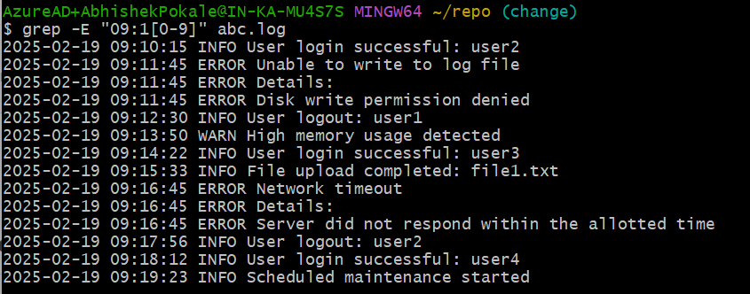

1. How many INFO messages are in the log file?

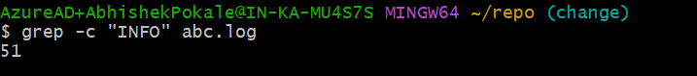

1. Print the first 5 lines of the file.

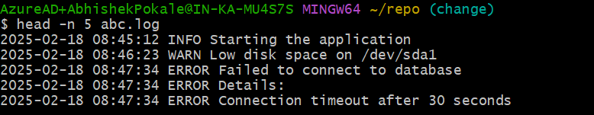

1. Print the last 5 lines of the file.

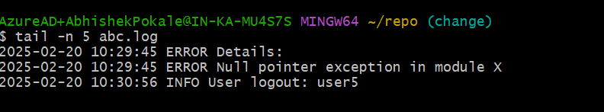

1. Print lines if the lines contain error, fail, or warning.

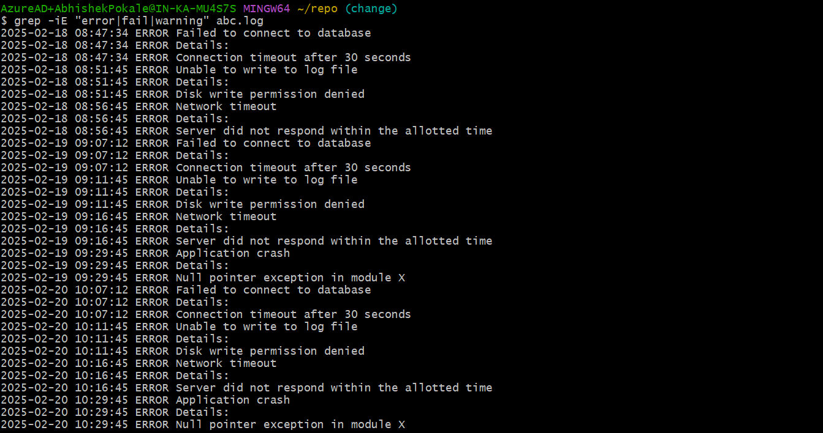

1. Rename the file to new_log.txt.



1. Edit the log file and add the string "hello, world!" at the beginning of the file.

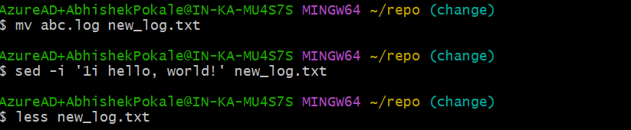

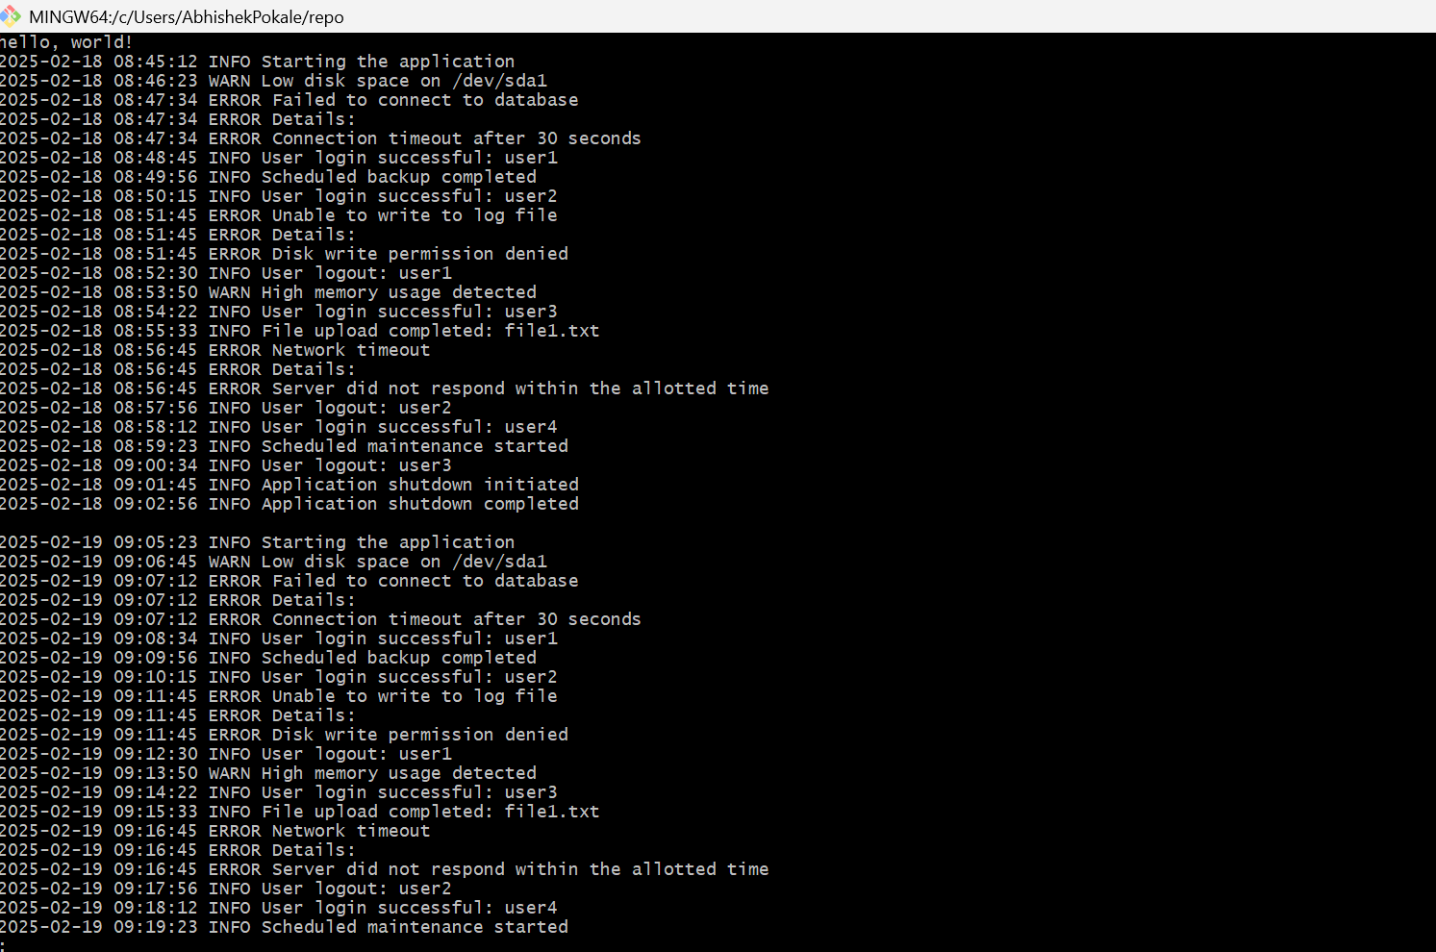

1. Delete the old log file.



1. Write a command to continuously monitor what is being appended to the file and output if you find the string "Error".

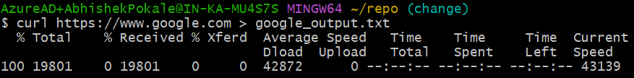

1. Connect to google.com and copy the output to a text file.   
   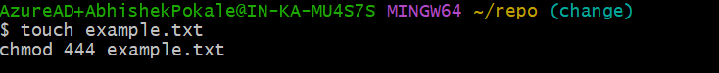
2. Create a file called example.txt. Write a script to make it read-only for all users.

**chmod +x myscript.sh**

1. Write a script that changes the permissions of a script named myscript.sh to make it executable by the owner, group, and others.

**chmod -R a+r /path/to/directory**

1. Recursively make all the files readable in a directory.

**chmod -R a+r /path/to/directory**

1. List out all the files that end with ".log" in a directory.

**find . -type f -name "*.log"**

1. Write a command to get the kernel version.

**uname -r**

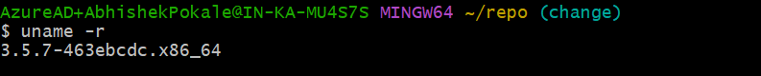

1. Find the IP address of the system.

**hostname -I**

1. Write a script to list all files and directories in the current directory, sorted by size.

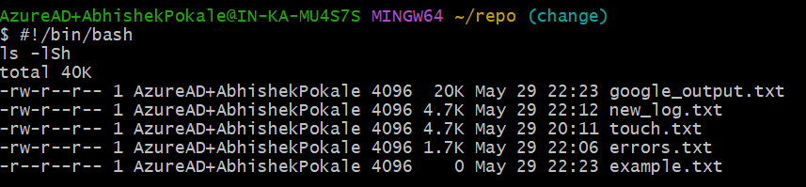

1. List all files and directories in the current directory with sizes in human-readable format.

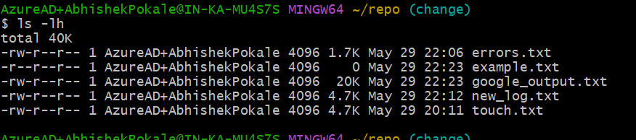

1. Print the hostname a computer.

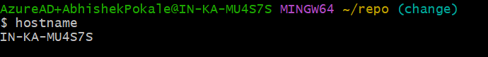

1. Command to Kill a particular process running in your system.

**Kill process_id**

1. Create two files test1.txt and test2.txt with some content and merge it to a single file test.text

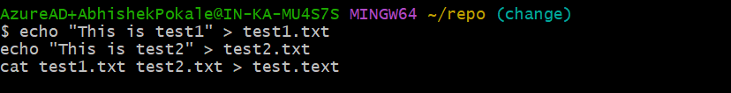

1. and 27 Create a shell script test.sh with the content given at the bottom and execute it.

Tes.sh creates mutiple process , wrtie command to kill some specific process with given pid.

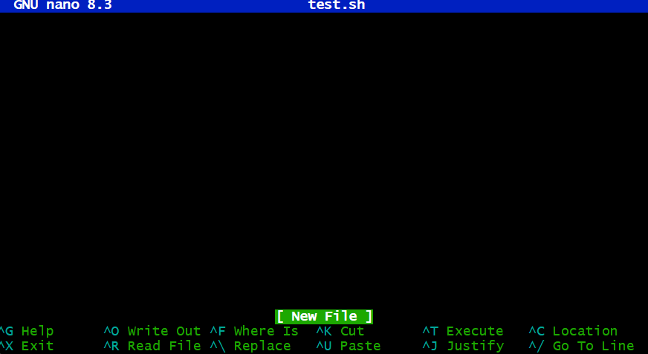



**ps aux | grep sleep**

**kill pid**

1. Write a shell script which take your name as input and it will dispaly Hello your name.

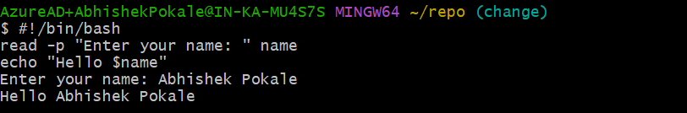

1. Write a command to download file.zip from  <https://github.com/github/gitignore/archive/refs/heads/main.zip>



1. Write a command to zip test.txt to test.zip and unzip it.

**zip test.zip test.txt**

**unzip test.zip**